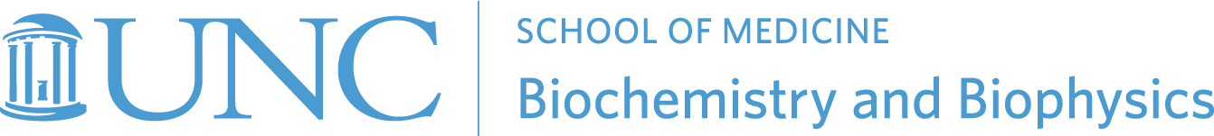

2024 Fall Seminar Series
Tuesdays at 11:00 AM in 1131 Bioinformatics

August 20
Vacant
Title: TBD

August 27
Vacant
Title: TBD

September 7
Wellness day- no seminar

September 10
Geeta Narlikar, Ph.D., Professor of Biochemistry and Biophysics and Vice Chair
University of California-SF --------------------------------------------------------Host: Brian Strahl
Title: TBD

September 17
Ioan Andricioaei, Ph.D., Professor of Chemistry
University of California-Irvine-----------------------------------------------------Host: Qi Zhang
Title: TBD

September 24
Vacant
Title: TBD

October 1
Vacant
Title: TBD

October 8
Vacant
Title: TBD

October 15 (Mary Ellen Jones Seminar)
Eva Nogales, Ph.D., Professor of Biochemistry and Structural Biology and Howard Hughes Investigator
University of California-Berkley------------------------------------------------------Host: MEJ committee
Title: TBD

October 22
Vacant
Title: TBD

October 29
Shahar Sukenik, Ph.D., Assistant Professor of chemistry and Chemical Biology
University of California-Merced -------------------------------------------------Host: Rebecca Berlow
Title: TBD

November 5
Lauren Porter, Ph.D., Distinguished Scholar and Stadtman Investigator
NLM-NIH --------------------------------------------------------------------------------Host: Brian Kuhlman
Title: TBD

November 12
Dylan Taatjes, Ph.D., Professor of Biochemistry
University of Colorado --------------------------------------------------------------Host: Jill Dowen
Title: TBD

November 19
Gissette Reyes-Soffer, Ph.D., Assistant Professor of Medicine
Columbia Vagelos College of Physicians and Surgeons -------------------Host: Saskia Neher
Title: TBD

November 26
Holiday week – no seminar

December 3
Adam Frost, M.D., Ph.D., Principal Investigator
Altos Labs ------------------------------------------------------------------------------Host: Rick Baker
Title: TBD

