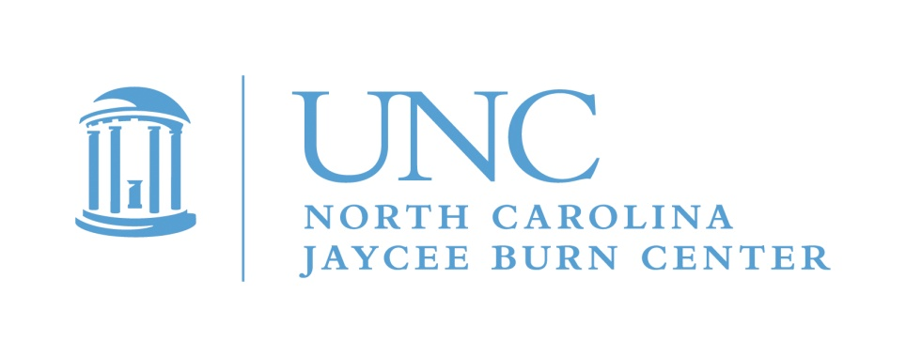
May 2024

Dear Teen Burn Survivor,

The North Carolina Jaycee Burn Center’s Aftercare Program would like to invite you to Teen Adventure Weekend 2024! This year’s adventure will happen August 16-18th 2024. This year we will be going to a new location! Teen Adventure Weekend will be held at Camp Hanes in King, NC. It will be an active weekend with lots of fun activities. This adventure filled weekend camp is for burn survivors, ages 13-18, who have not yet graduated high school. This is a free event! This camp is totally different from Camp Celebrate, so if you have never attended our teen only event, and have questions, please let me know.

Teen Adventure Weekend provides the opportunity for teen burn survivors to hang out and have fun with other teens who understand what it is like to have a burn injury as well as develop some useful life skills. As you grow and mature, you may discover that your burn has affected you in ways that you have not experienced before. Our facilitator this year was burned as a teen, and has lived through the challenges of having skin that looks different. Teens have told us that it helps to meet others their own age that know what it’s like to have been burned. You will see old friends, meet new ones, and maybe try some things you may not have done before! Whether your burn was large or small, recent or a long time ago, you are welcome to join us for the fun.

Space is limited to 24 campers, so sign up NOW if you are interested! Registration deadline is July 31st, 2024. Every year we have a waiting list for this event, and we do expect to fill up before the deadline. Please call 919-962-8427 or email Maria Albani for an application: Maria_albani@med.unc.edu . Applications are also available on the website and at the QR code below:
https://www.med.unc.edu/surgery/burn/burn-survivor-support/survivor-events/teenadvwknd
We like to split the spots evenly between males and females to the extent possible. If you go on a waiting list, we will let you know if a space opens. If you are interested in joining the adventure, return your application to:
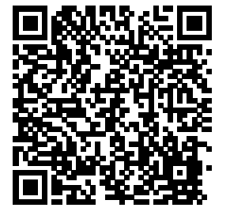
Teen Adventure Weekend attn.: Michele Barr
SCAN ME!
North Carolina Jaycee Burn Center
UNC Hospitals
101 Manning Drive, CB #7600
Chapel Hill, North Carolina 27599-7600

If you have any questions, please give me a call! 919-962-8427. We are looking forward to hearing from you. Once your teen has been accepted to the event their packing list and other event details will be sent to you. We hope you will join us for another great camp!

Michele

Michele Barr,LRT/CTRS
Aftercare Coordinator
The North Carolina Jaycee Burn Center
Main: (919) 962-8427
Fax: (919) 445-9704

