12/13 Individualization Phase Committee Meeting Meeting Minutes

- November minutes approved
- Welcome to Kelly Moore- newly joined the Charlotte team
- Dr. Sheri Jordan has left our team, Dr. Gus Parker is retiring soon as well- gratitude for what they have both contributed
- Dr. Meredith Neiss will be taking the lead for Indy phase
- Student updates: in interview season, successful med school gala, military match occurring tomorrow
- Campus updates:
  - Central: Course scheduling and lottery system is underway and going well
  - Charlotte: Working on figuring out special permission routes on One45
  - Asheville: no updates
  - Wilmington: no updates
  - Greensboro: no updates
  - Raleigh: no updates
- Dashboard report:
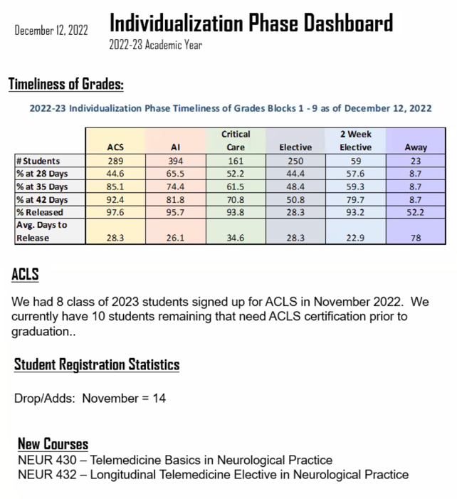
  - New courses approved
- Capacity and Competency Reviews from directors:
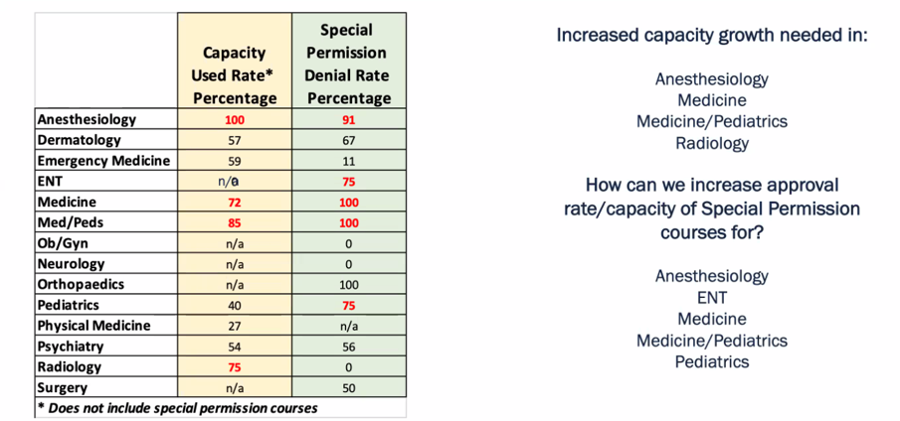
  - Elective director (Claire Larson): broke down which specialties most need increased capacity (anesthesia, pediatrics, medicine)
    - Hoping to create new course proposals, increase branch campus offerings, increase away rotations, and offer individualized experiences for students
    - For competencies: discussed variability of experiences, importance of clarifying objectives and expectations
  - Critical Care director (Dr. Jenny Maguire): capacity is very tight in critical care courses, majority are done at Chapel Hill ICU’s, will need to significantly increase capacity to accommodate more students in coming years
    - For competencies: many preceptors are used to CBA for residents/fellows, will consider adding more structure for comments for MSPE to add some consistency
  - ACS director (Dr. Morgan McEachern):
    - For capacity: increased capacity needed especially in certain specialties
    - For competencies: recently added PGA at beginning of rotations and have been using this as a way to test competency; looking at ways to use clinical preceptor evaluations to assess competency (how to standardize, how best to capture competencies in this way, potential need for CBA training for preceptors)
  - SHS5 director (Yee Lam): capacity struggle with faculty members available to grade assignments for SHS5 but not clinically based capacity problems
  - Discussion regarding special permission courses and why they are needed/can’t be opened up for the general lottery

